Experiment 3.3.2: Find if Path Exists in Graph
Mark as done
Experiment 3.3.2: Find if Path Exists in Graph UNIT 3 · EXPERIMENT 6
Practical Experiment Module · Chandigarh University

🔗 Course Outcomes — Experiment Mapping
CO | CO DESCRIPTION | BLOOM LEVEL
CO4 | Evaluate the efficiency of different algorithms and select the most appropriate structure and technique to solve challenging problems that require advanced data handling and optimization. | UNDERSTAND
📖 Manual of the Experiment
● 1. Aim
To implement a program that, given an undirected graph with n nodes and a list of edges, determines whether a valid path exists between a given source and destination node. The solution builds an adjacency list and runs a breadth-first search (BFS) in O(V + E) time and O(V + E) space.

● 2. Software Required
- Operating System: Windows 10/11 or Linux
- Programming Language: C++, Java, Python
- IDE/Editor: VS Code / CodeBlocks / IntelliJ IDEA / PyCharm / Online Compiler

● 3. Test Cases
Test Case 1:
Input: n = 3, edges = [[0,1],[1,2],[2,0]], source = 0, destination = 2
Output: true
Explanation: there are two paths from 0 to 2 - directly via the edge 2-0, or through 0 -> 1 -> 2.

Test Case 2:
Input: n = 6, edges = [[0,1],[0,2],[3,5],[5,4],[4,3]], source = 0, destination = 5
Output: false
Explanation: nodes {0,1,2} and {3,4,5} form two separate components, so 5 cannot be reached from 0.

Test Case 3:
Input: n = 1, edges = [], source = 0, destination = 0
Output: true
Explanation: the source and destination are the same node, so a path trivially exists.

● 4. Pseudo Code
START

INPUT n, edges, source, destination

BUILD adjacency list adj FROM edges

IF source == destination

RETURN true

CREATE visited[n] FILLED WITH false

CREATE empty queue

ENQUEUE source AND MARK visited[source] = true

WHILE queue IS NOT EMPTY

node = DEQUEUE

FOR each neighbour IN adj[node]

IF neighbour == destination

RETURN true

IF NOT visited[neighbour]

visited[neighbour] = true

ENQUEUE neighbour

RETURN false

END

● 5. C++ Code
#include <iostream>
#include <vector>
#include <queue>
using namespace std;

bool validPath(int n, vector<vector<int>>& edges, int source, int destination) {
vector<vector<int>> adj(n);
for (auto& e : edges) {
adj[e[0]].push_back(e[1]);
adj[e[1]].push_back(e[0]);
}
if (source == destination) return true;
vector<bool> visited(n, false);
queue<int> q;
q.push(source);
visited[source] = true;
while (!q.empty()) {
int node = q.front(); q.pop();
for (int next : adj[node]) {
if (next == destination) return true;
if (!visited[next]) {
visited[next] = true;
q.push(next);
}
}
}
return false;
}

int main() {
vector<vector<int>> edges = {{0,1},{1,2},{2,0}};
cout << (validPath(3, edges, 0, 2) ? "true" : "false") << endl;
return 0;
}

● 6. Java Code
import java.util.*;

public class FindPathExists {
public static boolean validPath(int n, int[][] edges, int source, int destination) {
List<List<Integer>> adj = new ArrayList<>();
for (int i = 0; i < n; i++) adj.add(new ArrayList<>());
for (int[] e : edges) {
adj.get(e[0]).add(e[1]);
adj.get(e[1]).add(e[0]);
}
if (source == destination) return true;
boolean[] visited = new boolean[n];
Queue<Integer> q = new LinkedList<>();
q.add(source);
visited[source] = true;
while (!q.isEmpty()) {
int node = q.poll();
for (int next : adj.get(node)) {
if (next == destination) return true;
if (!visited[next]) {
visited[next] = true;
q.add(next);
}
}
}
return false;
}

public static void main(String[] args) {
int[][] edges = {{0,1},{1,2},{2,0}};
System.out.println(validPath(3, edges, 0, 2));
}
}

● 7. Python Code
from collections import deque

def valid_path(n, edges, source, destination):
adj = [[] for _ in range(n)]
for u, v in edges:
adj[u].append(v)
adj[v].append(u)
if source == destination:
return True
visited = [False] * n
queue = deque([source])
visited[source] = True
while queue:
node = queue.popleft()
for nxt in adj[node]:
if nxt == destination:
return True
if not visited[nxt]:
visited[nxt] = True
queue.append(nxt)
return False

print(valid_path(3, [[0, 1], [1, 2], [2, 0]], 0, 2))

● 8. Learning Outcomes
1.Understand graph representation using an adjacency list.
2.Learn how breadth-first search (BFS) explores a graph level by level.
3.Improve logical thinking and problem-solving skills in DSA.
4.Understand how connected components determine reachability between nodes.
5.Understand implementation in C++, Java, and Python.

● 9. Reference books
1. Data Structures and Algorithms Made Easy — Narasimha Karumanchi
2. Problem Solving with Algorithms and Data Structures Using Python — Brad Miller and David Ranum
3. The C++ Programming Language — Bjarne Stroustrup
4. Core Java — Cay S. Horstmann and Gary Cornell
🎥 Relevant Demonstration Video
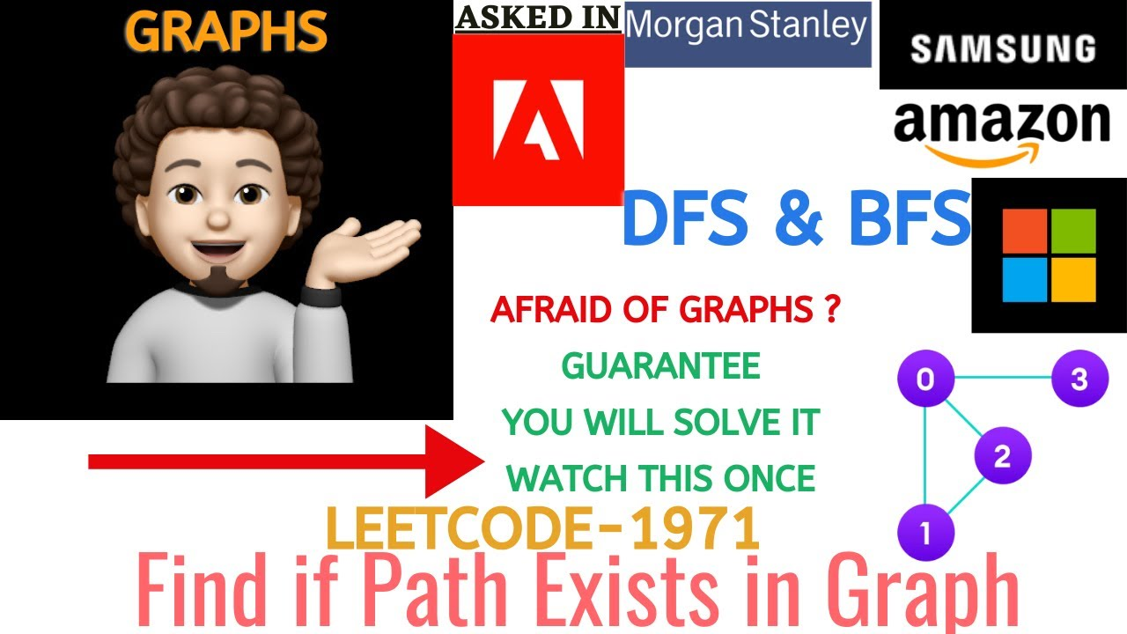
▶ Watch on YouTube: https://youtu.be/mbR1XSXidEE
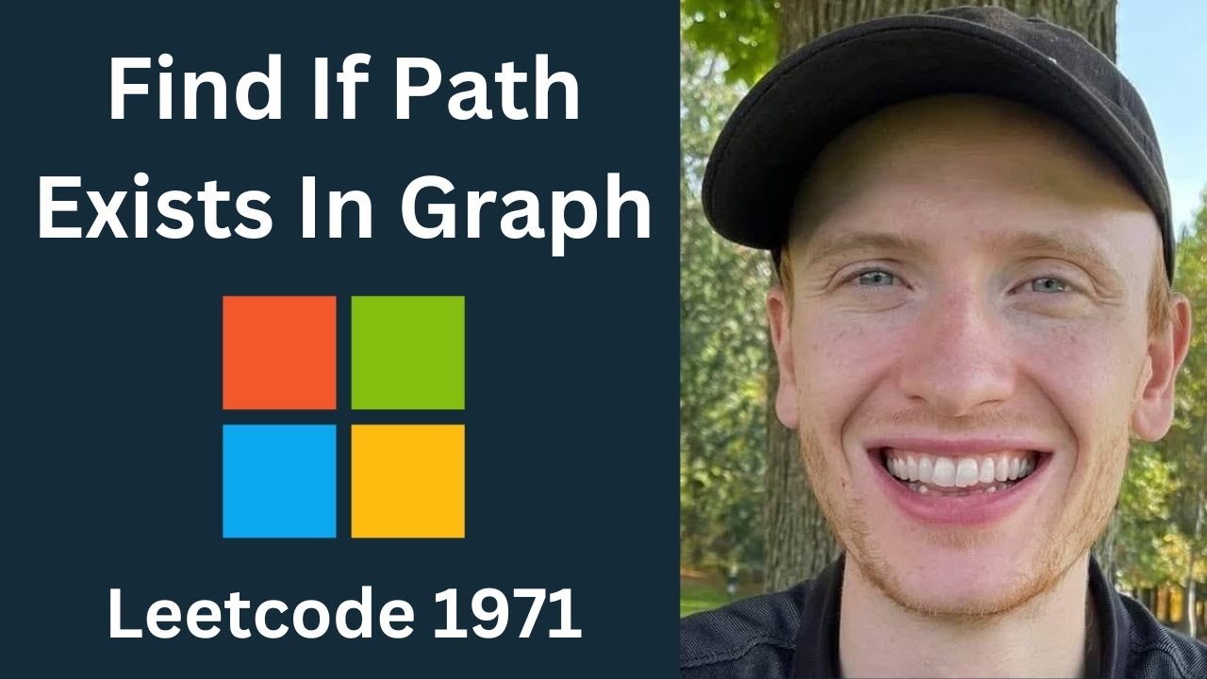
▶ Watch on YouTube: https://youtu.be/knLFe7hEp3Y

📊 Applications Mapped with Course Outcomes
📈 Network routing  Checking whether two devices on a network can communicate through a series of links. | 📈 Social networks  Determining whether two people are connected through mutual friends.
📈 Maze solving  Deciding whether an exit cell is reachable from a starting cell. | 📈 Maps & navigation  Checking whether a destination is reachable from a source location by road.
📈 Dependency resolution  Verifying whether one module can be reached through a chain of dependencies. | 📈 Circuit design  Testing whether two terminals are electrically connected in a circuit.
❓ Frequently Asked Questions (FAQs)
Q1. What is the difference between BFS and DFS for this problem? CO1
Either traversal works for a reachability check. BFS visits nodes in order of distance from the source using a queue, while DFS goes as deep as possible first using recursion or a stack; both give the same yes/no answer.
Q2. Why do we mark nodes as visited? CO4
A graph can contain cycles, so marking nodes as visited stops us from revisiting them, which avoids infinite loops and ensures each node is processed only once.
Q3. What are the time and space complexities? CO4
Time is O(V + E) because every vertex and edge is examined once, and space is O(V + E) for the adjacency list together with the visited array and the queue.
🔗 Other Resource Materials
🎓 NPTEL Lecture
This resource provides a theoretical foundation on graph traversal and breadth-first search, essential for understanding the experiment's logic.
🔍 Open search →

🧪 Simulation Tool
Using a visual simulation helps students watch BFS spread outward from the source node across the graph.
🔍 Open search →

📄 Research Paper
This paper offers a rigorous analysis of graph-search algorithms and reachability, validating the efficiency claims made in the lab experiment.
🔍 Open search →
Cards open prefilled searches on each portal. Faculty / students pick the most relevant result.

